The goal of this project is to determine the future of 219 Provencher Blvd. and 212 Dumoulin St. based on public feedback. We want to know your thoughts on the future of this space and what is important to you.

How to Use This Guide
This Community Discussion Kit will help you guide a discussion about the future of 219 Provencher Blvd. and 212 Dumoulin St. To plan and host a discussion:
- Review the package
- Plan your event and invite friends, family, neighbours or community members
- Follow instructions for forming groups and the different roles to assign
- Discuss the topics and make notes during the conversation
- Return the document with feedback to provencherdumoulin@winnipeg.ca

Agenda
- Background | Share the background available in this package or the project webpage.
- Form Groups | If your event has more than ten participants, you may wish to get into groups of 4-6.  Each group should assign three key roles:  Facilitator - The facilitator will ensure the group stays on track and will ensure everyone is heard throughout the discussion.  Note taker - The note taker will record the discussion and check with the group to ensure their feedback is captured correctly.  Reporter - The reporter will report back to the larger group by providing a summary of the discussion.
- Introductions | Each member of the group should introduce themselves.  Share your name and your reason for participating in this community workshop.
- Discussion | Use the pages in this kit to guide the discussion.
- Sharing | All of the discussion groups can come together to share what they discussed. The reporter can provide a summary to the larger group.
- Next steps and close | Ensure everyone knows that they can visit winnipeg.ca/provencherdumoulin to subscribe for updates and take the survey.
Please return this completed document to provencherdumoulin@winnipeg.ca by
February 15, 2024 or call 204-986-4243 to make alternate arrangements. Thank you!

Background
The Saint-Boniface Civic Square is the heart of the former City of Saint-Boniface. The City of Saint-Boniface was amalgamated with the City of Winnipeg in 1972. The property and collection of buildings remains an important space for francophone art, culture, and services, and represents the history of Manitoba and how francophone people shaped the province. Although the square is seen for its importance as a unified property, the focus of this project is on two of the buildings:

219 Provencher Blvd.  - Former Saint-Boniface City Hall  - Built in 1905  - Listed as a historical resource in 1981  - City offices are no longer needed in this building  - Currently used as office space for several organizations | 212 Dumoulin St.  - Former Saint-Boniface Fire Hall No. 1  - Built in 1907  - Listed as a historical resource in 1987  - City offices are no longer needed in this building  - Currently vacant and needs renovation
The Saint-Boniface Civic Square
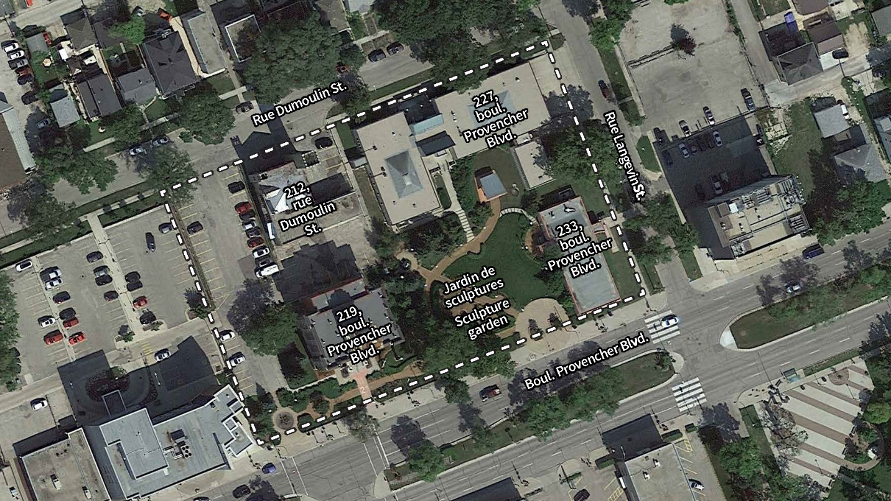
219 Provencher Blvd. & 212 Dumoulin St.:  Decide the future using input from the public engagement process |  | 227 Provencher Blvd.:  Council approved the sale in December 2012 | Sculpture garden and 233 Provencher Blvd.:  Existing leases to continue (not part of public engagement)
 | Saint-Boniface Civic Square Boundary (Note – 227 Provencher Blvd. Is privately owned)

Key Terms
Community Organization – An organization that is connected to or involved in the francophone community and demonstrates they are going to meet conditions as defined by stakeholder and public engagement.
Sale - A transfer of property where the seller (vendor) gives all property rights to the buyer (purchaser) in exchange for money. In this case, the City is the vendor and would evaluate sale offers from potential purchasers. The best offer will be selected, which does not necessarily mean the highest price gets the property.

Lease – An agreement where the owner of a property (lessor) agrees to the property being used for a specified time and use by a renter (lessee), usually in return for compensation. In this case, the City would be the lessor and the lessee would have control of the property (subject to the negotiated terms and conditions). A long-term lease (spanning years or decades) can provide stability and certainty for the owner of the property and the renter.
Market price – The current price an asset can be bought or sold for. For buildings, this is typically determined by allowing for anyone to make a bid and the supply and demand for similar properties will determine how much bidders are willing to pay for it.

What is happening now?
On July 13, 2023, Council directed that the Public Service undertake public engagement regarding sale and/or lease options for the future use of 219 Provencher Blvd. and 212 Dumoulin St. and report back regarding the future use of 219 Provencher Blvd. and 212 Dumoulin St. based on public engagement for sale and/or lease options.
We are listening to the community and allowing their voices to help guide the future of this space. This means exploring all of the options available and finding out what conditions would be required to move forward.

What happens next?
Feedback from your discussion and other discussions will be analyzed along with survey feedback to find out who we heard from, what is most important, and key themes. After we know the community’s views, we will meet with key stakeholders again to discuss the results and ensure their voices and the voices of the community will be accurately reflected in a report to Council. To support their decision-making, Council will receive the feedback along with a recommendation for the future of the 219 Provencher Blvd. and 212 Dumoulin St.
Please complete this section:
What is the name of your organization?
How many participants attended your discussion?

_________


Discussion Theme #1 – The Civic Square today

Discussion: As a group, discuss the overall strengths, weaknesses, opportunities, and challenges to the entire Saint-Boniface Civic Square.

Strengths  What works well with the buildings currently? | Weaknesses  What does not work well?
Opportunities  Do you have ideas to improve on the weaknesses or build on strengths? | Challenges  Are there elements that constrain the opportunities for change?

Discussion Theme #2 –219 Provencher Blvd. and 212 Dumoulin St. today

Discussion: As a group, discuss the overall strengths, weaknesses, opportunities, and challenges to 219 Provencher Blvd. and 212 Dumoulin St. Please note which building you are referring to when recording the discussion in the table below.

Strengths  What works well with the buildings currently? | Weaknesses  What does not work well?
Opportunities  Do you have ideas to improve on the weaknesses or build on strengths? | Challenges  Are there elements that constrain the opportunities for change?


There are a few options for the future of the buildings, which will determine who owns the buildings and how they are maintained and managed.
Discussion Theme #3 – Future options

The details of a sale or lease are not yet determined but would have to meet certain conditions.
What are your views on each of the options listed below? Discuss as a group and identify which options belong in which category below and why.
- City sells the building to the highest bidder
- City sells the building to a community organization for a reduced cost, rather than considering profit as a main factor
- City rents the building to the highest bidder
- City rents the building to a community organization who pays maintenance costs only
- City enters a long-term lease (rental agreement) with a community organization to manage the buildings
Read the key terms in the background section for an understanding of the differences between these options.
Options to consider | Why?
Options to avoid | Why?

Buildings and properties can be a lot of different things. A building’s uses and design can create different experiences.
Discussion Theme #4 – What do you want to experience?

Take a moment to think about what do you want to experience when you visit in the future?
This could include:
- which services are offered
- how you want to feel when you visit the space
Discuss with the group and then narrow down your discussion to three key words.
Notes:

Three key words to describe what we want to experience:

Additional notes:

Additional notes:

