ARCHIVES STRATEGY
Virtual Workshop

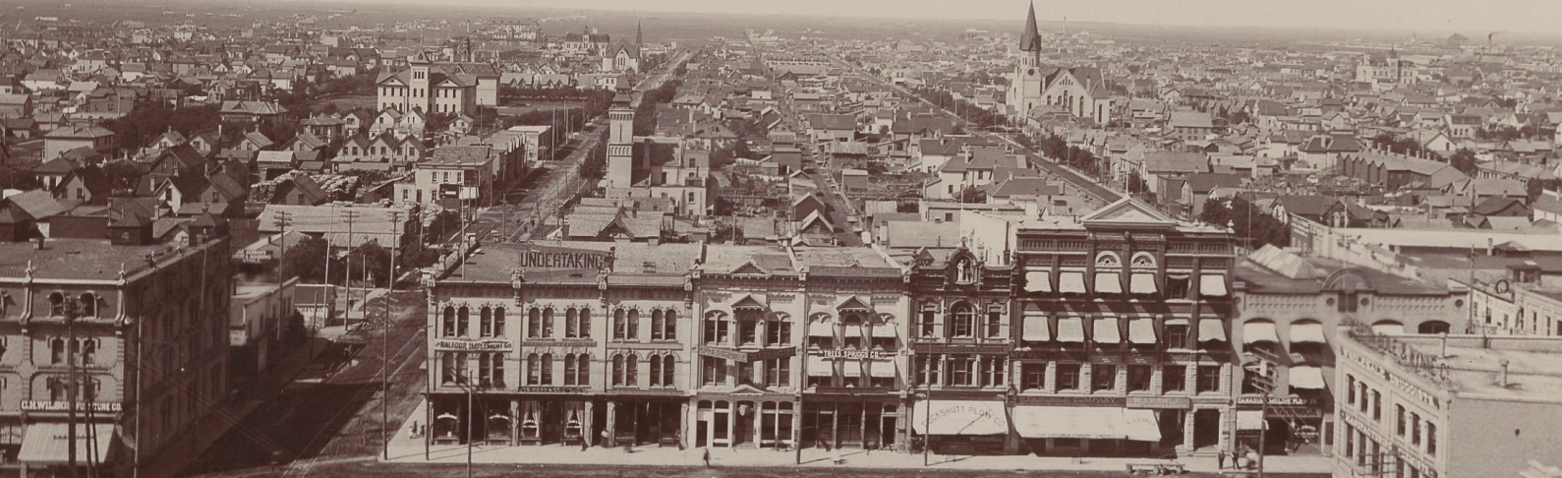

June 2021 (2 hours)

winnipeg.ca/archivesstrategy
To ensure long-term preservation and access to irreplaceable records, the City is exploring facility options to address the storage and preservation needs for its growing archival collection, to allow enough space for its programming, and to create an accessible space that allows Winnipeggers to continue to have access to records and conduct research.
Purpose:
- Provide background and approach
- Discuss and gather feedback on service improvements
- Discuss and gather feedback on facility options

Agenda
Activity | Details | Duration
Introductions | Introduce the project team and participants | 5 min
Presentation | Provide background  Introduce approach, data collected, outcomes of consultant study, and updates | 25 min
Activity overview | Introduce discussion topics | 5 min
Group discussion  Part I: Service Improvements | Group discussion  Answer questions | 20 min
Report back | Share group insights | 10 min
BREAK (15 min)
Group discussion  Part II: Facility Options Evaluation | Discuss options  Answer questions | 20 min
Report back | Share group insights | 10 min
Next steps & closing | Short overview of next steps  Please circulate to your network | 10 min

Part I: Service Improvements (20 min)

Goal: Discuss needs of community members and get feedback on proposed service improvements.
Step 1: Each group member introduces themselves to the rest of the group including their name, organization, and one word to describe how they feel about the City of Winnipeg Archives.
Step 2: Assign one group member as the recorder/reporter to take notes and present back to the larger group
Step 3: As a group, discuss the service improvements proposed by the archives study (refer to page 3).
  - Are there any services you would like to see that aren’t there?
  - Which services do you think are most important?

Notes:
[insert notes]

Service Area | Current Services | Service Improvements
Public Programming | - Offsite programming at schools  - Developing materials for offsite displays  - Limited programming and support of smudging ceremonies | - Programming and events hosted on-site including tours, classes, lectures, discussion panels, book launches, photo exhibits, film nights, and receptions  - Displays hosted on-site, curated by the City of Winnipeg Archives  Expanded opportunities for:  - Indigenous ceremonies, storytelling, and programming  - Community outreach and partnerships with community organizations and school/university programs  - More engagement with the public, tourists, students, and visitors
Research | - Providing assisted and non-assisted research, primarily occurring in the reading room | - Additional capacity for researchers  - More dedicated and better-equipped research stations allowing access to both physical and born-digital records  - Better environment for review of audio and video
Archival Services | - Archival records storage and preservation | - Moderate conservation services including humidification, flattening, and cleaning  - Additional digitization efforts  - Processing and acquiring digital records
Other | - Small and infrequent additions to the archival collection  - Regular operating hours Monday to Friday, 8:30 a.m. to 4:30 p.m. | - Increased storage space for archival material from community sources (individuals, families, companies, organizations)  - More accommodating operating hours including limited evening and possibly weekend hours

Option # | Description | Estimated Cost (Class 3)
Option 1 | Construct a new building for the Archives to meet needs for up to 20 years. | $22.3 million
Option 2a | Two Archives sites: a City-owned downtown site for public access with additional storage space at an offsite location. | $25.8 million
Option 2b | Similar to Option 2a, but downtown location leased. | $20.0 million (not including lease)
Option 3 | Similar to Option 1: construct a new building to meet needs for up to 10 years, with an expansion in 10 years. | $23.7 million
Option 4 | Renovation of 380 William Ave. for Archives. | $13.3 million (not including hazmat removal)

In 2019-2020, the City’s Archives and Records Control Branch engaged Cornerstone Planning Group to review the facility needs of the Archives and to develop several options to meet these needs.

The options were developed with the following assumptions:
- All options should be prepared with a Class D estimate (Opinion of Probable Cost; equivalent to Class 3 estimate of -20% to +30%).
- All options should be for a 20-year planning horizon.
- Both consolidated (one site for archival records, services, and programs) and distributed (two sites: one for public access and a second for additional offsite storage) models should be considered.
- Review suitability of 380 William Ave. for the Archives.
- The estimated cost does not include purchase of the property.

Note: Estimated costs are preliminary and should not be viewed as the final or total project costs.
While the consultant found that Option 1 and Option 4 were most suitable, the City of Winnipeg is still exploring its options.
The Public Service is presenting the options that are currently identified. We plan to recommend one of these options for Council’s consideration. Ultimately, it is Council’s decision regarding how to move forward which may include exploring additional options in the future.

Part II: Facility Options Evaluation (20 min)

Goal: Gather feedback on the options explored by the consultant’s study
Step 1: Review the options described on page four.
Step 2: Provide initial responses to options
- How do you see your needs and priorities reflected in the options?
- Were any options missed?
Step 3: Discuss how each option addresses the values identified by stakeholders earlier in the process and complete the table.
All facility options are required to meet several requirements:
• Environmentally controlled vault space (Class A) for 20-years of collections growth
• Functional space for archival, digitization, and conservation activities
• Public programming and display space to support access and knowledge transfer
• Research space to provide for increased activity in an appropriate setting
• Administrative space supporting staff growth to 20-years
In speaking with stakeholders, they noted several values that they would like to see reflected in the future archives space, in addition to requirements. How well do you think each option meet the values outlined by stakeholders earlier in the process?
Complete the table below to identify a response for each option and each value: Does not reflect the value; somewhat reflects the value; completely reflects the value; not applicable/not sure. Add comments to support your response as well.
Notes:
[insert notes]

Value | Option 1  New building to meet needs for twenty years | Option 2a  Two archives sites, both city-owned | Option 2b  Two archives sites, downtown space leased | Option 3  Mew building to meet needs for ten years | Option 4  Renovation of 380 William Ave. | Other option
Response options  (copy best fit into spaces below) | Does not reflect the value | Somewhat reflects the value | Completely reflects the value | Not applicable | Not sure | Not enough information to answer
A central and convenient location

Ability to support growth and diversification of the archival collection

Ability to accommodate growth of the archives

Connection to a heritage building or heritage site

[insert another value]

[insert another value]

[insert another value]

Thank you for participating today!

